**STEPS FOR ADD PAGINATION OR PAGE LIST IN MVC PROCESS**

1. **First step**
   1. **You need to installing**
      1. X.PagedList(8.0.7)
      2. X.PagedList.Mvc.Core(8.0.7)
      3. Use after install on controller
         1. using X.PageList;
      4. Use after install on Index.cshtml
         1. @model IPagedList<Employees.Models.Employee>
         2. @using X.PagedList;
         3. @using X.PagedList.Mvc.Core;
         4. @using X.PagedList.Mvc.Core.Common;
2. **Second step add this code to your controller**

public ViewResult Index(int? page)

{

// Get items as IQueryable<Book> and convert to IPagedList<Book>

// Page min value is 1.

ViewData["Title"] = "Index";

return View(_context.Employees.ToPagedList(page ?? 1, 5));

}

1. **Third step add this code to your view**

@Html.PagedListPager(Model, page => Url.Action("index", "Employees",

new { page = page }),

new PagedListRenderOptions

{

LiElementClasses = new string[] { "page-item" },

PageClasses = new string[] { "page-link" }

})

1. **The Four Step**

**Detail Page**

1. **Second step**

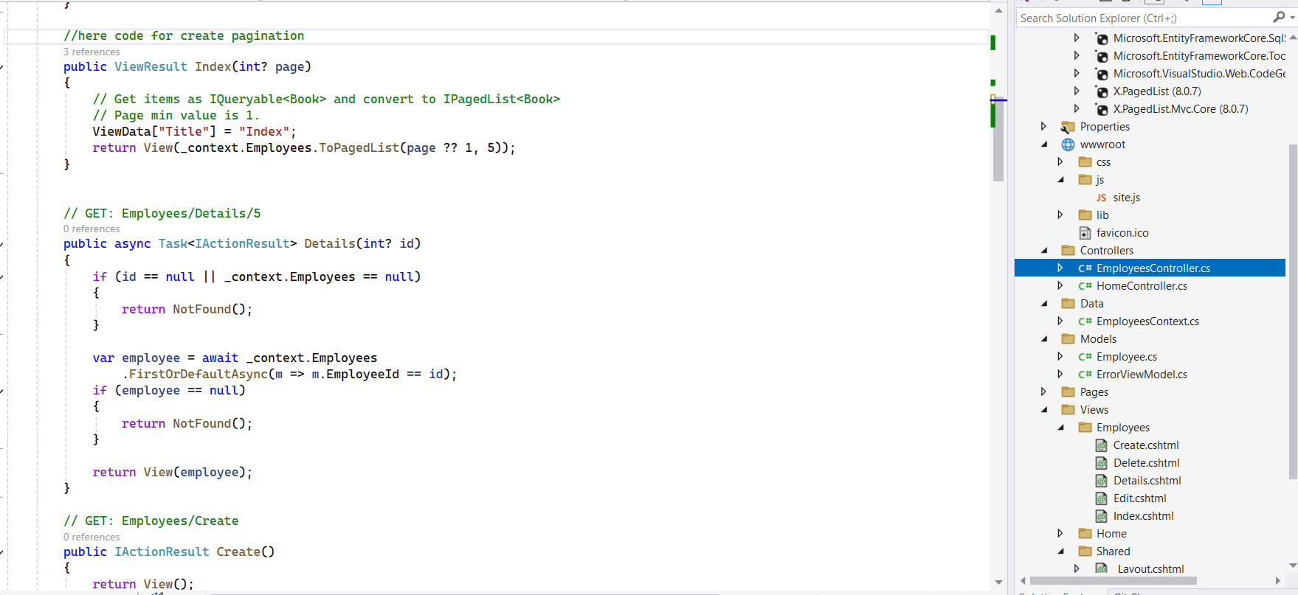

Use it after installing

Table name

Database

1. **Third Step**

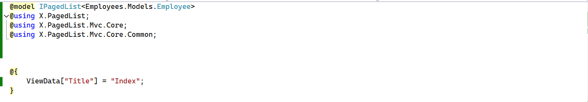

File name in view

1. **The End………..**